Council District 6
Parks Recreation and Community Services Updates, October 2025
CM Boylan

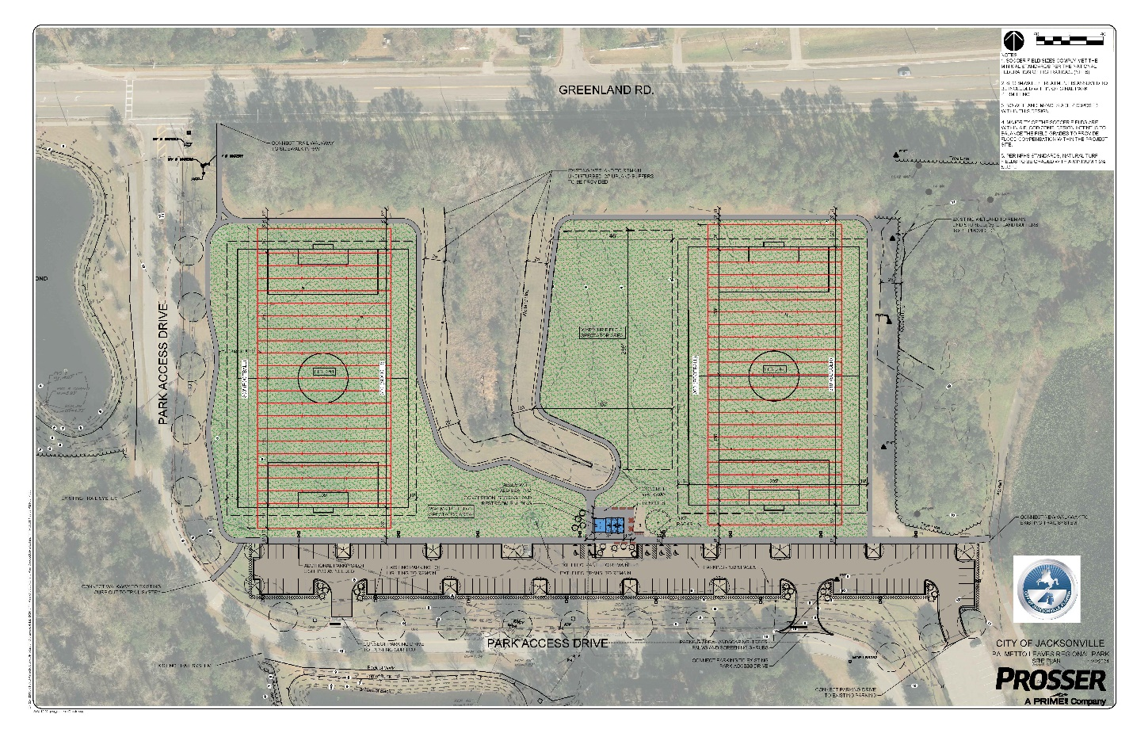
Palmetto Leaves Park
- 2 Flex Fields, Restroom, Playground
- Plans to bid, Winter,2026
- Complete, Fall, 2026

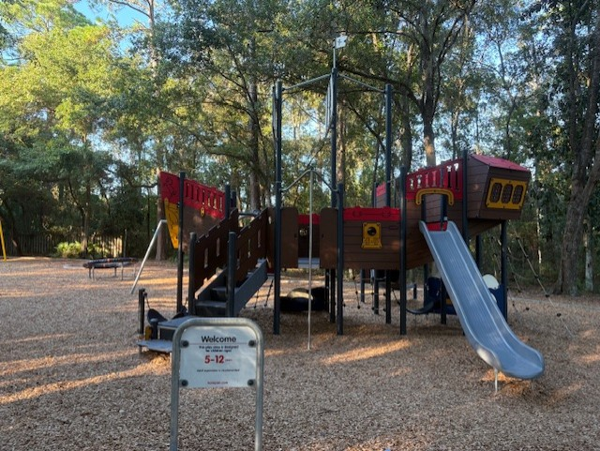

Tommy Hazouri Park
- Playground Complete
- Paddle board vendor bid, Winter, 2026

Other park projects in process:
- County Dock: speed hump, Completed
- Walter Jones/County Dock: rapid flashing beacon between church parking lot and Walter Jones, Completed
- Walter Jones: Harriet Beecher Stowe sculpture Completed
- Julington-Durbin Park: restroom and parking lot: Completed
- Losco, new pavilion near playground: Spring, 2026
- Alberts Field:
  - Completed
    - Replace maintenance gates
    - Develop alternatives to bollards
    - Tree work
  - Winter 2025
    - Demo existing playground
    - Install dog park fencing and entry concrete pads.
  - Spring 2026
    - New sidewalks connecting the dog park with the parking lot.
    - Install crush-crete parking lot in the north section of the park with timber curbing and 1-board fencing surrounding the planters/islands.
  - Spring/Summer 2026
    - Install new playground and site furniture with connections to existing walkways (Design TBD)

